Jeppiaar Institute of Technology

sriperumbudur -638 401,Kanchipuram District ,Tamil Nadu

DEPARTMENT OF INFORMATION TECHNOLOGY.

WEB PHISHING DETECTION

(**ASSIGNMENT 1)**

DATE : 23-11-2022

PROBLEM : TO ANSWER THE QUESTIONS FOR THE ANSWERS

NAME: ABISATH A B

OUTPUT : SCREENSHOTS:

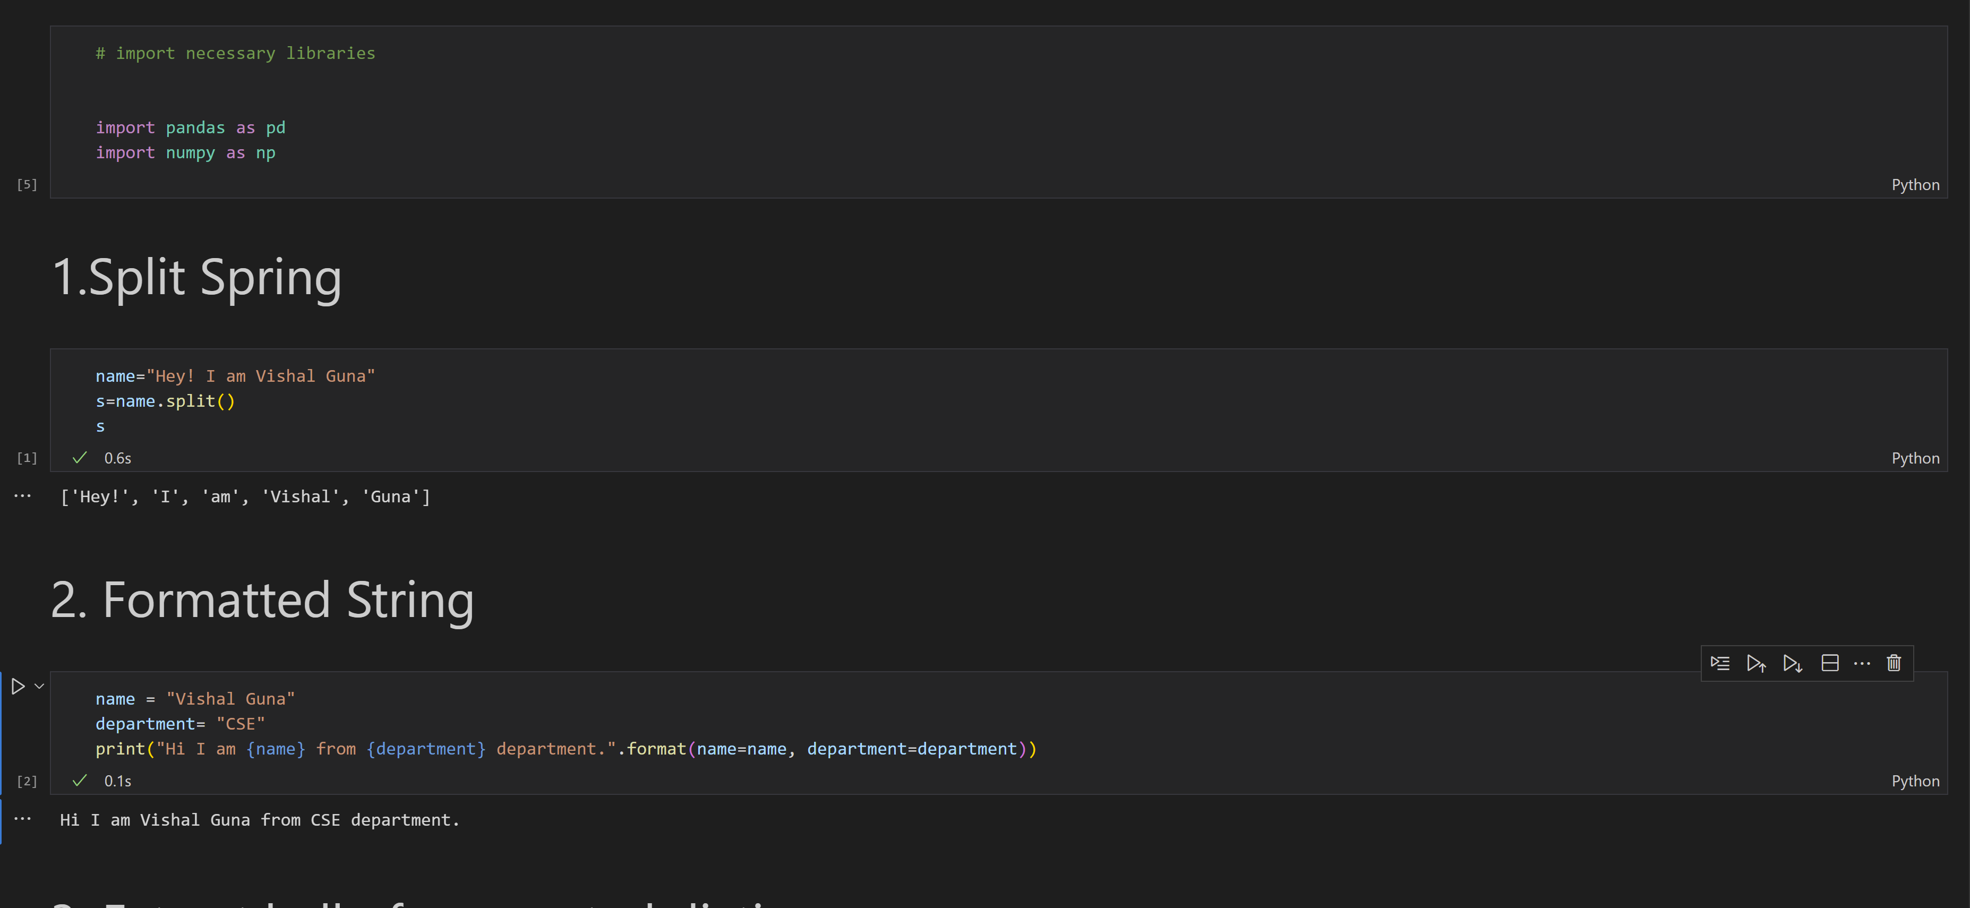

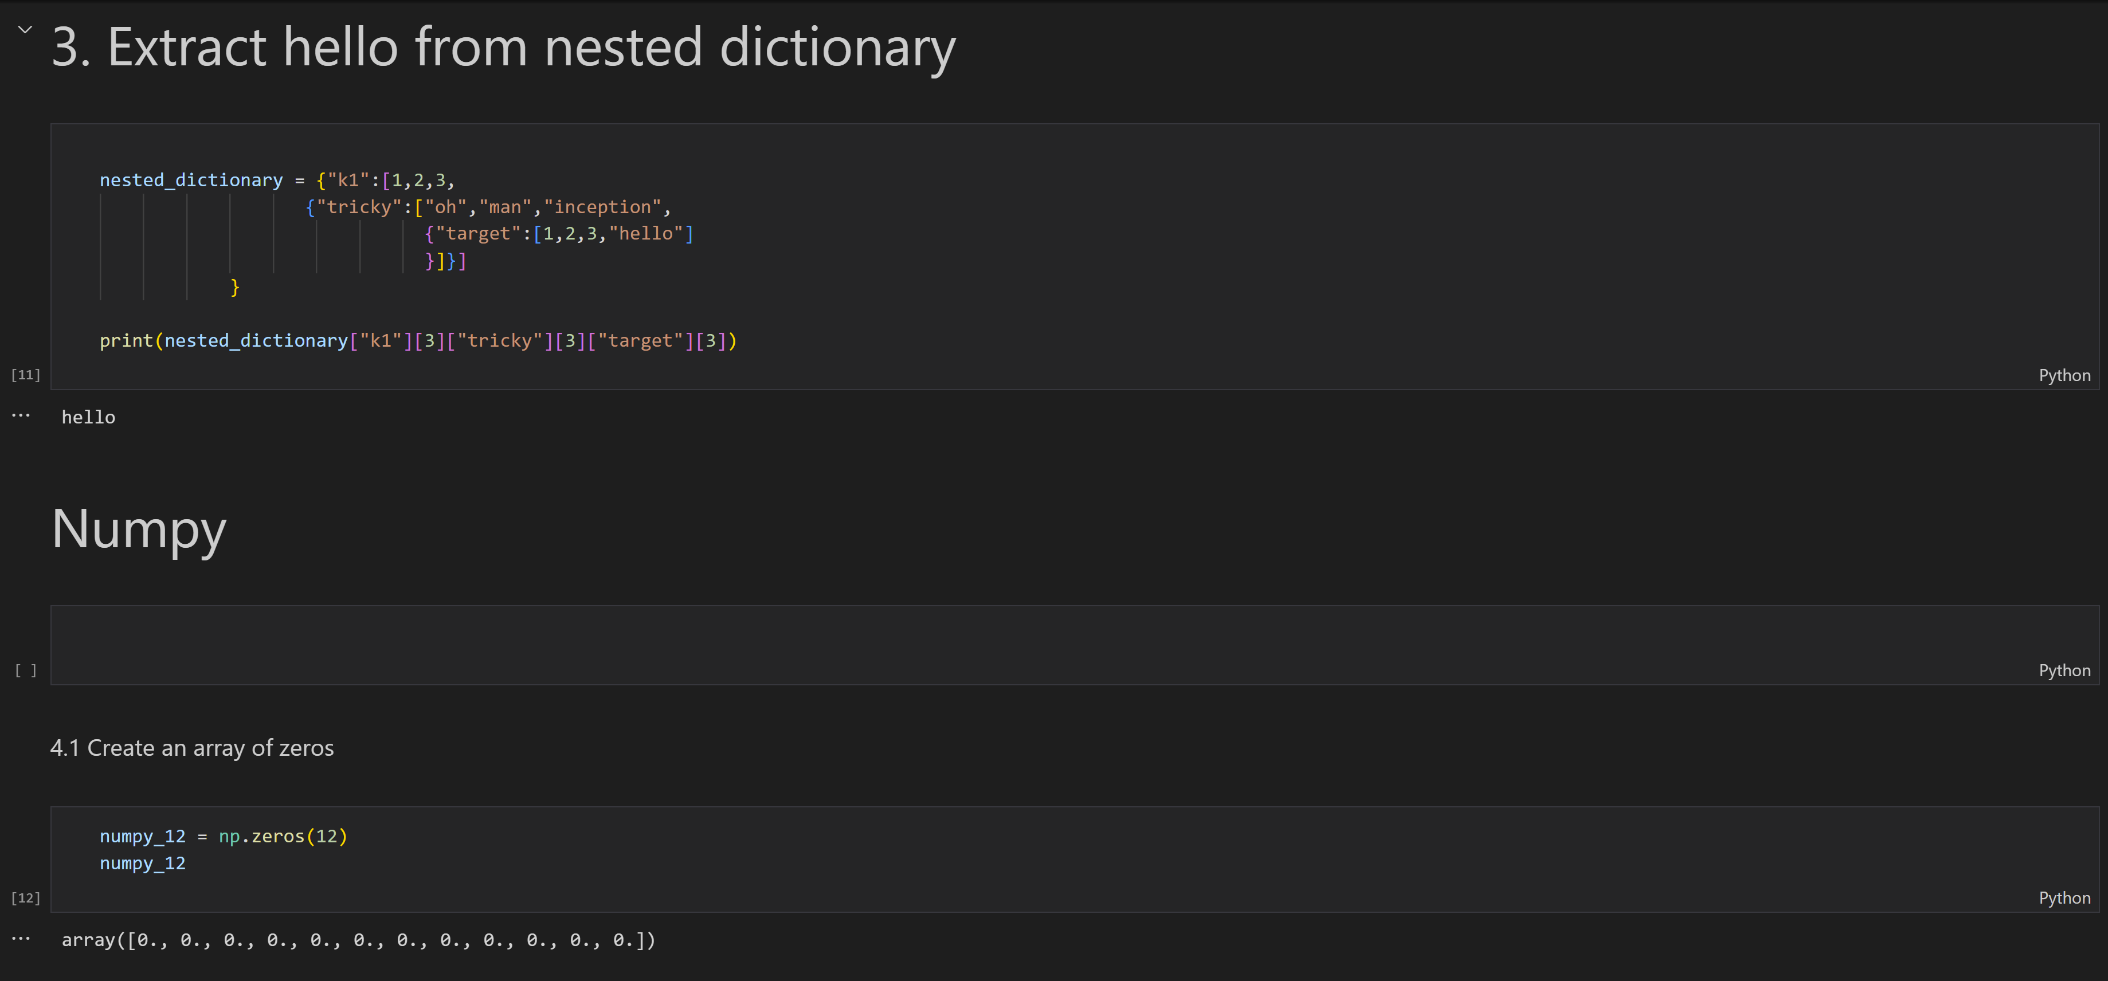

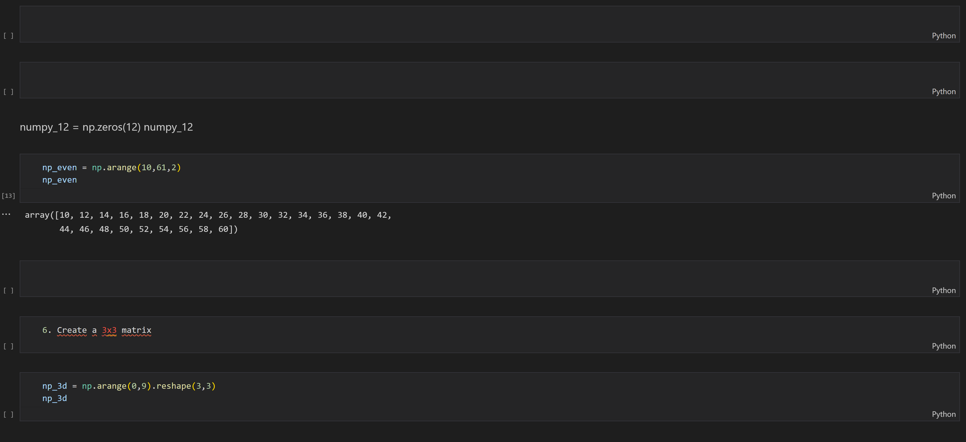

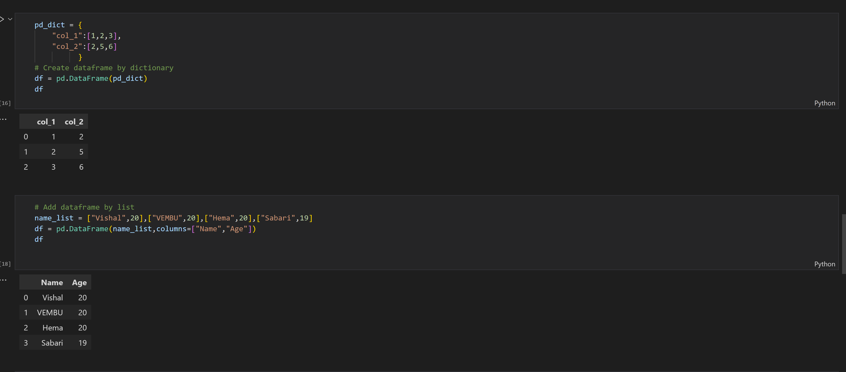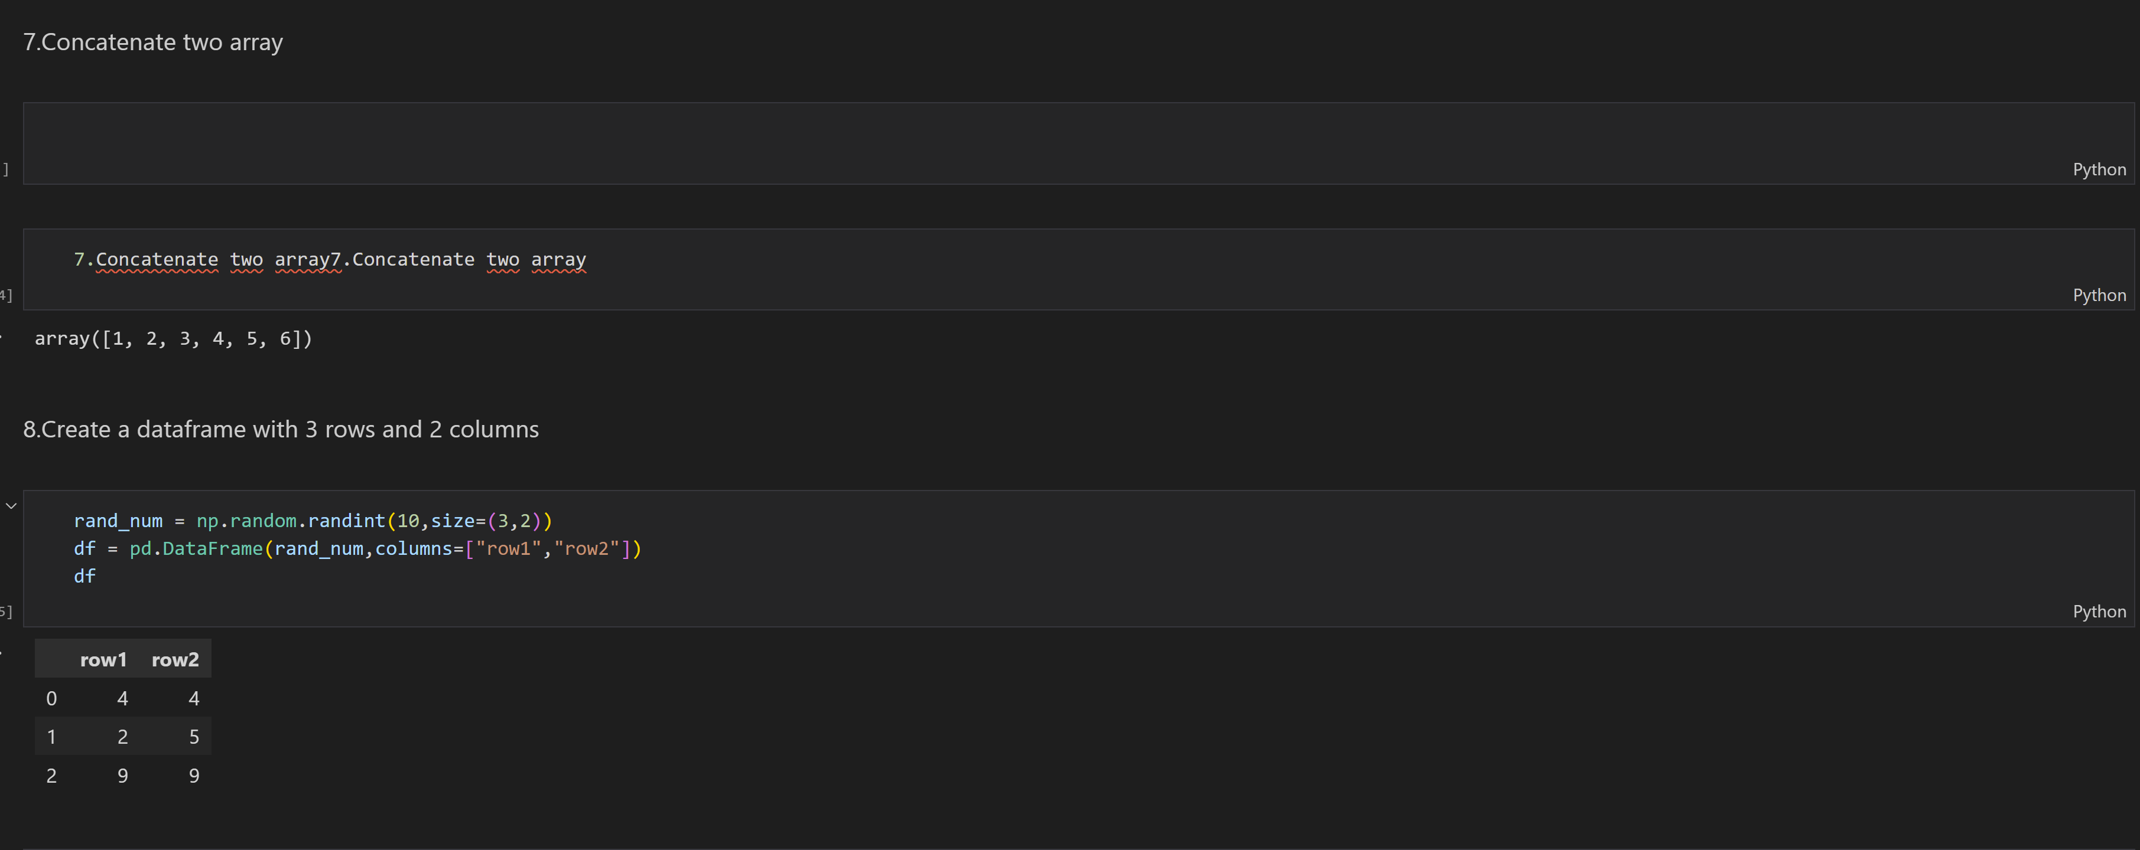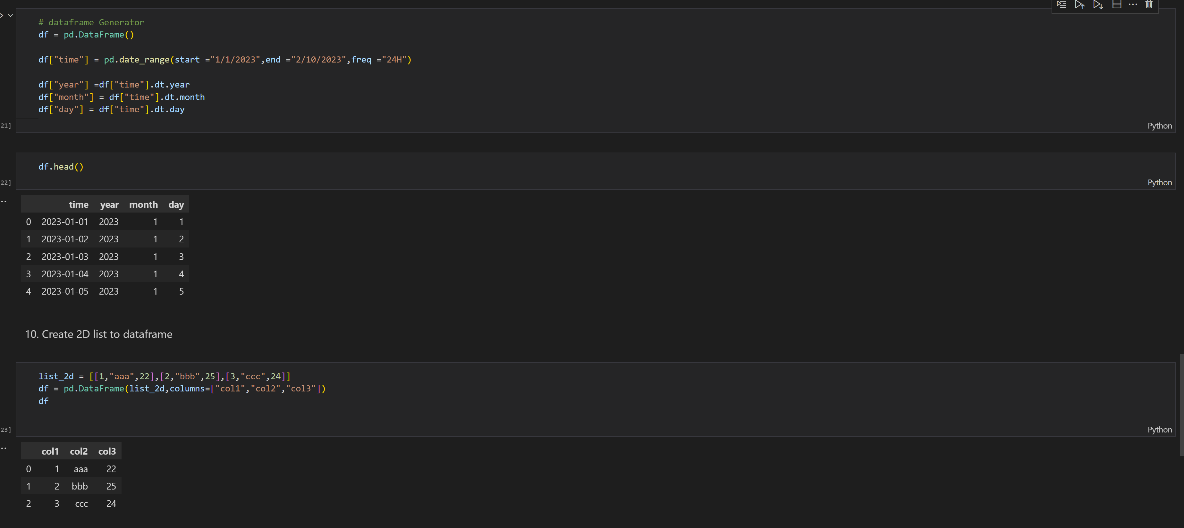

******************************THANKING YOU***********************************